Champion T2-2 total station firmware upgrading:
1. Uncompress the .bin install file, and copy it to My Device/Storage card of T2 total station
2. Make sure battery power is full for program install, because the whole process can take up to 15 minutes to complete.
3. Select My Device/Control Panel
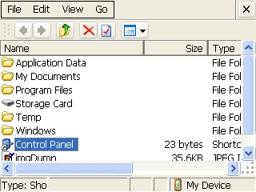

4. Select and run System Update (SYS UPD) in Control Panel menu.
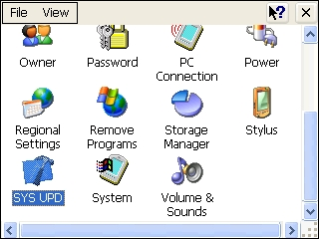

5. Click Load to find the file “NK_A_CHAMPION_ENG_TEMP.bin”.
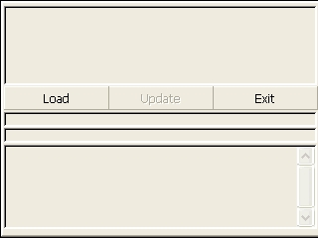

6. Click Update.
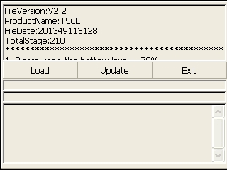

7. The install will then begin, and the progress bar will show the stages updating.
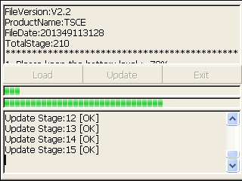

8. After reaching the final stage, “All Upgrade Complete Successfully” will be displayed.
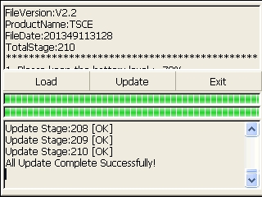

9. Return back to the main menu, and turn off the instrument.
10. Your T2-2 is now up to date, and you are ready to go to work.

